On October 31, 1517, Martin Luther nailed his famous 95 Theses to the Castle doors of Wittenberg. This event set into motion a massive uprising of peoples in Germany, Europe and the British Isles against the Roman Catholic Church for its many abuses of the common man, its fraudulent and malicious money- making schemes and its obvious and egregious departures from Holy Scripture. Over the next hundred years countries all over Europe and the British Isles broke fellowship with the Pope and his Holy Roman Empire, the most dominant religious empire in history. Religious wars sprang up all over Europe. The Edict of Nantes of Henry IV of France, and the Letter of Majesty of Emperor Rudolf II were attempts to qualm the violence and see peace restored in Europe. These attempts would be short lived. Ferdinand II, Holy Roman Emperor, educated by the Jesuits, began his persecution of Protestants and instigated the Thirty Years War from 1618-1648. The Protestants, led by Gustavus Adolphus, King of Sweden, won this great religious war leading to the Nationalistic Treaty of Westphalia and the beginning of modern History. The Protestant Reformation created Nationalism in the West. Before this treaty Europe and the British Isles were subsumed under the Roman and Greek Empires. Ethnic distinctions were always deluged by the Universalist Imperial programs of Greece and Rome. This idea of Nationalism, Western Civilizations with distinct ethnic identities, a national church and language is a Protestant creation. Madison Grant states in his The Passing of the Great Race, page 85, “The Church of Rome has everywhere used its influence to break down racial distinctions. It disregards origins and only requires obedience to the mandates of the universal church.” This universalist racial policy is a product of the Pope’s claims to be the head of Christ’s Church, his Vicar on Earth. Quinquagesimo Ante, On his Sacred Jubilee, Pope Pius XI – 1929,

“For Italy is Our own country, the country in which the overruling hand of God placed and fixed the See of His Vicar on earth. He placed it here in Rome, which had been the capital of that marvelous, yet limited empire, thus making it capital of the entire world. For thus it became the seat of a sovereignty that surpasses all national and political boundaries, that embraces all men and all peoples…”

This Catholic Ultramontanism is the exact demographic policy we are brow-beaten into accepting in the United States on a daily basis. In the Mass Media and in your Universities you will be told that Nationalism has been the cause of the greatest wars over the past century and a new United Nations style Imperialism must take its place. The Church has been busy over the past hundred years setting up this Political theatre because they failed to win back the British and Northern European people to the Catholic Church. Apologetics failed so they turned to a policy of racial pity. Our modern Political Climate is more-or-less an arcane tempest conjured by the Catholic Church in order to punish us for our sins of “obstinacy” and in all their unhinged religious fanaticism the word “racist” carries just as much portentous ire as the ancient libel of “heretic” carried a few centuries ago. Yet, I would not leave you with mere ideological or thematic similarities between our modern Political climate and the Church. I would like to document for you the exact men who have created this modern political disaster and their direct affiliations with the Roman Church.

In the 17th and 18th centuries the order of the Jesuits began a system of missionary work called “Reductions” in order to Catholicize native peoples in Spain, Argentina, Brazil, Bolivia and America. The economic system utilized in these immensely productive and profitable Reductions was Communism. The success of these Reductions and the power achieved by the Jesuits drew alarm from the traditional Church leading to their suppression with the Papal Bull Dominus ac Redemptor Noster 1773 issued by Pope Clement XIV. This Civil War, of sorts, within the Catholic Church, led to the Jesuit embrace of the Social Justic Theology of Joachim of Fiore who called for the end of second age traditional Catholicism and the third Age of Social Justice Monkery to take its place. A famous movie was made cinematizing these events: The Mission, 1986, featuring Jeremy Irons and Robert De Niro. This is the most important era of Modern Political History you have most likely never heard of. There is a very good reason for this: you will have your life destroyed if you talk about it in professional circles. This was realized by Sociology and Anthropology Professor Richard Kane at Illinois State University. He specialized in this field and focused his course work on this topic and for it he had his life destroyed and was forced to leave the country after numerous death threats. The Jesuit Reductions in South America are the volcano from which our modern Political tempest springs. It is no accident that the countries in the world with the most devout and financially successful White Protestant populations were the exact targets for the modern “Civil Rights” movements: England and much of Northern Europe having defected to Darwinism, the Southern states of North America and the Boers of South Africa were to be the targets. The Muslim nations, Muhammad Ali (1769-1849) being the most prolific slave trader of all time, and South America itself were far more prolific in the Transatlantic slave trade, yet the two groups of people who had the least involvement in the shipping-trade itself, having no large fleets or resources (the New England Rum Factories producing the most popular means of exchange at the time) to obtain the slaves from the African continent, are blamed the most for the plight of Black men in the modern world! We were directly targeted because we are the most successful devout Protestant peoples on the Earth.

The pre- and post-Civil War political climate was full of warnings of a Conspiracy to flood the United States with Catholics in order to subvert the Political Structure of the United States. From the Know Nothings in New York led by William Poole, made famous as “Bill the Butcher” in the movie Gangs of New York (2002) to Samuel Morse, the Ku Klux Klan in the South to Charles Chiniquy and Jeremiah Crowley in Midwest, the mid to late 19th century was awash with alarm that the Irish and Italian Catholic immigrants were causing in the United States. This led to the passing of The Johnson Reed Act of 1924. This act was specifically designed to keep the United States Protestant in its demographics. The Conspiracy theorists were right! The Civil Rights era was dominated by Catholic influence specifically designed to overturn the Johnson Reed Act. Martin Luther King Jr. was mentored by a man named A. Philip Randolph. Randolph, of course, also being a member of the Jesuit Created Methodist Church. Randolph’s mentor was a Jesuit priest by the name of John LaFarge Jr., who in effect was the actual Father of the Civil Rights era. MLK was also championed by Pope Paul VI. The United States Commission on Civil Rights consisted of Theodore Hesburgh, a Catholic Priest and President of the Catholic University of Notre Dame; Jesse Ernest Wilkins Sr., a graduate of Jesuit hotbed University of Chicago law school and a member of the Jesuit created Methodist Church; Doyle E. Carlton, also a graduate of Jesuit hotbed University of Chicago. The Civil Rights Act of 1964 was originally proposed by Irish Catholic President John F. Kennedy. The prominent influence behind the Immigration and Nationality Act of 1965 was Irish Catholic Ted Kennedy and his brother Robert Kennedy, both continuing the Catholic program of their brother JFK. The man who introduced the bill, Emanuel Celler, was also the man who repaired diplomatic relations between the United States and the Papacy with his letter to U.S. Secretary of State Cordell Hull. Jesuit Catholic Georgetown University has been for decades the official University of American Law. Crusade accomplished!

The history of South Africa is identical. The Boers of South Africa are a group of people who fled Europe after the Edict of Fontainebleau repealed protection of Protestants in France. The French Protestants along with many Northern Europeans from Germany and Switzerland joined the Dutch Protestants in the Cape Colony in order to find religious freedom and employment with the Dutch East India Company in South Africa. They were all staunchly Protestants. Through many wars and struggles the Boers created a first-world civilization in what was once called the Transvaal. In 1886 and following, gold and diamond mines were discovered near Johannesburg and other areas of the Transvaal making it the richest nation in Southern Africa. The British, having betrayed the Reformation for Darwinism and being infiltrated by Jesuit priests after their suppression in 1773 via the Masonic Lodge, seethed in jealousy as the Boers protected their wealth for themselves and discriminated against the British Uitlanders. Jesuit agent Cecil Rhodes wanted the Boer gold and diamonds and created the first anti-apartheid movement called the Jameson Raid. It failed. The British tried again with Second Boer War and succeeded. The Boer gold and diamonds now in the hands of the British, the hated Protestant Boers, refusing to accept Masonic Darwinism and integrate into British culture, had to be eliminated. Cecil Rhodes funded the creation of a new Black Liberation party with his Izwi Labantu Newspaper soon to form into the South African Native National Congress later known as the African National Congress. (ANC) In a Petition to King George V, from the South African Native National Congress, July 20, 1914, the South African Native National Congress professed their loyalty to the British Crown and pleaded for its protection. The ANC was the weapon by which the Jesuit controlled British Empire would continue to destroy the once great Protestant Boers. ANC leader Nelson Mandela and British trained Anglican Bishop Desmond Tutu led the second Jameson Raid against the Boers now known as the fall of Apartheid. For their service to the Pope they were awarded knighthoods in the famous Catholic Order of Saint John.

The modern Civil Rights movements have nothing to do with helping black people. They are an inquisition against the ancient enemies of the Pope. I would refer you to my website southernprotestant.com for more information.

Drake Shelton
southernmessianics@gmail.com

The Roman Catholic

Agenda Behind the Modern Anti-White Movements
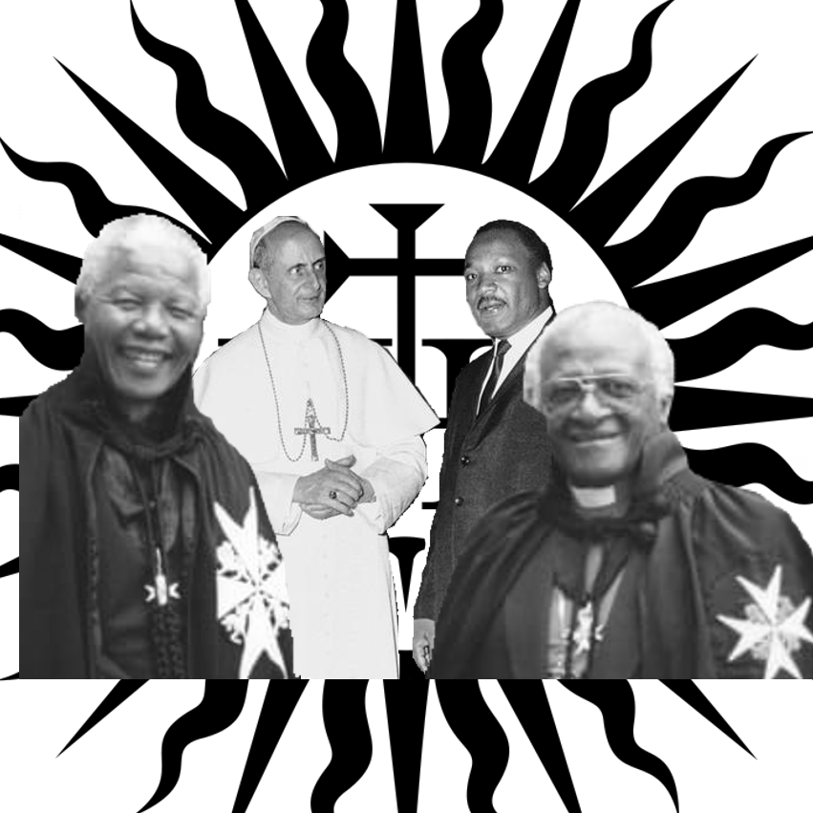

“We can have the United States in ten years. And I want to give you three points for your consideration: The Negroes, the Indians and the public schools." — Archbishop John Ireland, Rome, 1892 - The American Eagle, Oct. 24, 1895, page 4

southernprotestant.com

William Prynne, Hidden Works of Darkness, pg. 89
The Last Will and Testament of Cecil John Rhodes, ed. W.T. Stead, 56, 64, 66
Iris Berger, South Africa in World History, 75

